ENGINEERING TOOLS – ENGR 110
LAB 4 – SolidWorks

PURPOSE: To continue to practice using SolidWorks.

DESCRIPTION:

A. Two drawings without tutorials:
a) Complete Problem 1.1 at the end of Chapter 1 in your textbook. Looks like this:
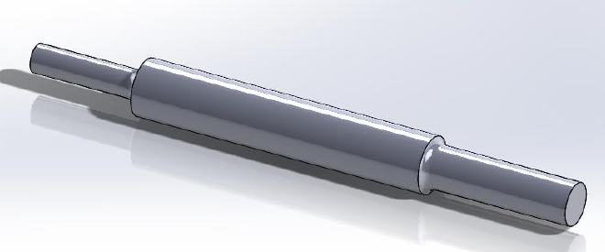
b) Complete Problem 1.2D at the end of Chapter 1 in your textbook. Note here that you only have to do figure D. Looks like this:
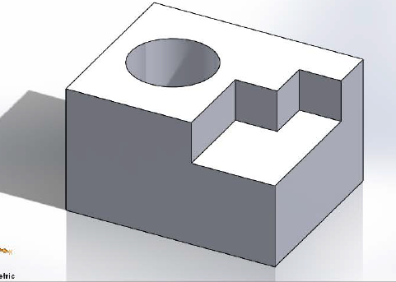

B. Complete the Introduction to Solidworks Tutorial from the SolidWorks GETTING STARTED TUTORIALS (same place the Lesson 1 tutorial is located. It looks like this:
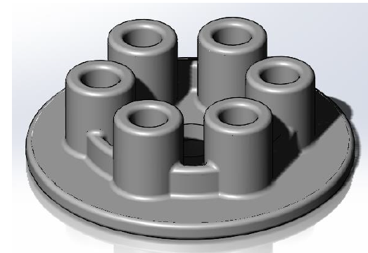
NOTE 1: you do NOT need to do the part of this tutorial that has you do the engineering drawing for this part. You can stop when you have finished drawing the part.
NOTE 2: you should skip the part of this tutorial that has you do the countersink holes for screws. The tutorial leads you through the steps for this task and then tells you to delete them because you don’t need them.

C. Complete the Engineering Drawing tutorial in Chapter 2 of your Textbook (sections 2.1 and 2.2). NOTE: you do not have to complete section 2.3 for this tutorial. Looks like this:
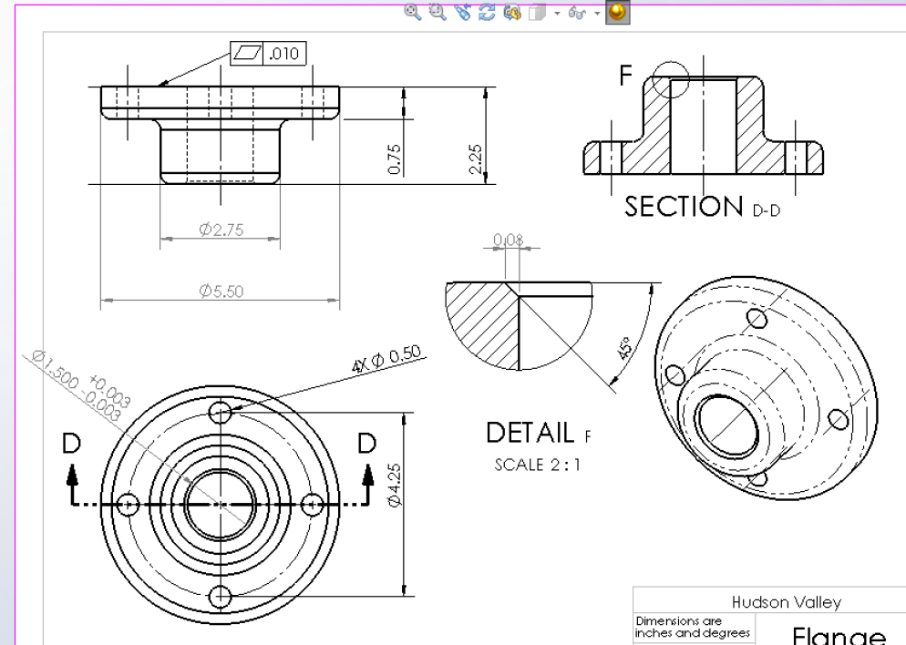

DELIVERABLES: (Trimetric views are expected for the solidworks work.)
For each figure, provide a front (trimetric view). You should be handing in the following solidworks drawings:
1. Two 3-D drawings from part A above. (one for problem 1.1 and one for problem 1.2D)
2. One 3-D drawing from part B above.
3. One 3 view engineering drawing from part C above.

EVALUATION:
Each will be evaluated based on completeness and content.

